Here is a complete, professional documentation guide for your Enterprise Disaster Recovery and Google Drive Backup System. You can export this directly to a .pdf or Markdown file for your internal engineering team or technicians.

System Architecture & Disaster Recovery Documentation
Module: Secure Cloud Backup & Bare-Metal Restore System
Version: 1.0.0

1. System Overview
This system provides an enterprise-grade, fully automated disaster recovery (DR) solution for local POS (Point of Sale) instances. It securely encrypts local PostgreSQL databases and configuration files, uploads them to a central Google Drive via Google Apps Script, and provides a 1-click, bare-metal restore interface via a Flutter frontend.

Key Features:
- AES-256 Encryption: All database backups are encrypted locally before transmission. The cloud only stores .enc ciphertext.
- Self-Healing State Tracker: Uses a local "write-ahead log" (syncTracker) to resume interrupted cloud setups after power outages or internet loss.
- Automated Retention Policy: Google Drive automatically purges old backups, keeping only the 3 most recent files to save storage space.
- Blind Recovery: Technicians or clients only need their Outlet Code to initiate a full system rebuild.

2. Cloud Backend (Google Apps Script)
The Google Apps Script acts as a serverless API broker between the local Node.js application and Google Workspace (Drive & Sheets).

Supported API Actions:
- verify_and_get_client: Cross-references the provided Outlet Code against the central Google Sheet database and locates the assigned Google Drive folder ID.
- upload_config: Saves/overwrites the config.enc and config.json files in the client's Drive folder.
- upload_backup: Accepts Base64 encoded, AES-encrypted .enc database backups.
- clean_old_backups: Scans the client's folder, sorts files prefixed with backup_ by date, and moves all but the 3 newest to the trash.
- download_latest_backup / download_config: Streams Base64 file data back to the client for local restoration.

3. Client Initialization (initClient)
When the POS system starts, the initClient routine guarantees the local machine is perfectly synchronized with the cloud.

The "Sync Tracker" Architecture
To prevent duplicate Google Drive folders or infinite loops caused by unexpected server crashes, the system uses a sync_status.json tracker.
- Offline Resilience: If an upload fails due to network issues, the specific task (e.g., config_synced) remains false.
- Next-Boot Recovery: On the next login, the system reads the tracker, skips completed tasks (like folder creation), and immediately resumes the failed uploads.
- Optimized I/O: The master client.json file is only written to the hard drive if core identity changes occur, preventing unnecessary disk degradation.

4. Automated Backup Pipeline
Backups are handled by a background Cron job configured to run hourly (0 * * * *). To prevent memory leaks, a global lock (isBackupJobRunning) ensures only one instance of the scheduler runs per application lifecycle.

The Backup Lifecycle:
- Extract: spawn safely streams data from PostgreSQL via pg_dump, completely bypassing Node.js memory limits.
- Compress: The .sql file is piped into an archiver (zlib level 9) to create a ZIP stream.
- Encrypt: A random 16-byte Initialization Vector (IV) is generated and prepended to the output file. The ZIP stream is piped through an aes-256-cbc Cipher.
- Rename: The output file is explicitly named .enc (e.g., backup_2026-03-21_09-00-00.enc) to prevent the host OS from falsely identifying it as an empty or corrupted ZIP archive.
- Upload & Prune: The .enc file is uploaded via the Apps Script API, followed immediately by the clean_old_backups command.

5. Bare-Metal Restore Process (Disaster Recovery)
If a client machine suffers catastrophic hardware failure, the system can be completely rebuilt on a fresh PC using the Flutter frontend.
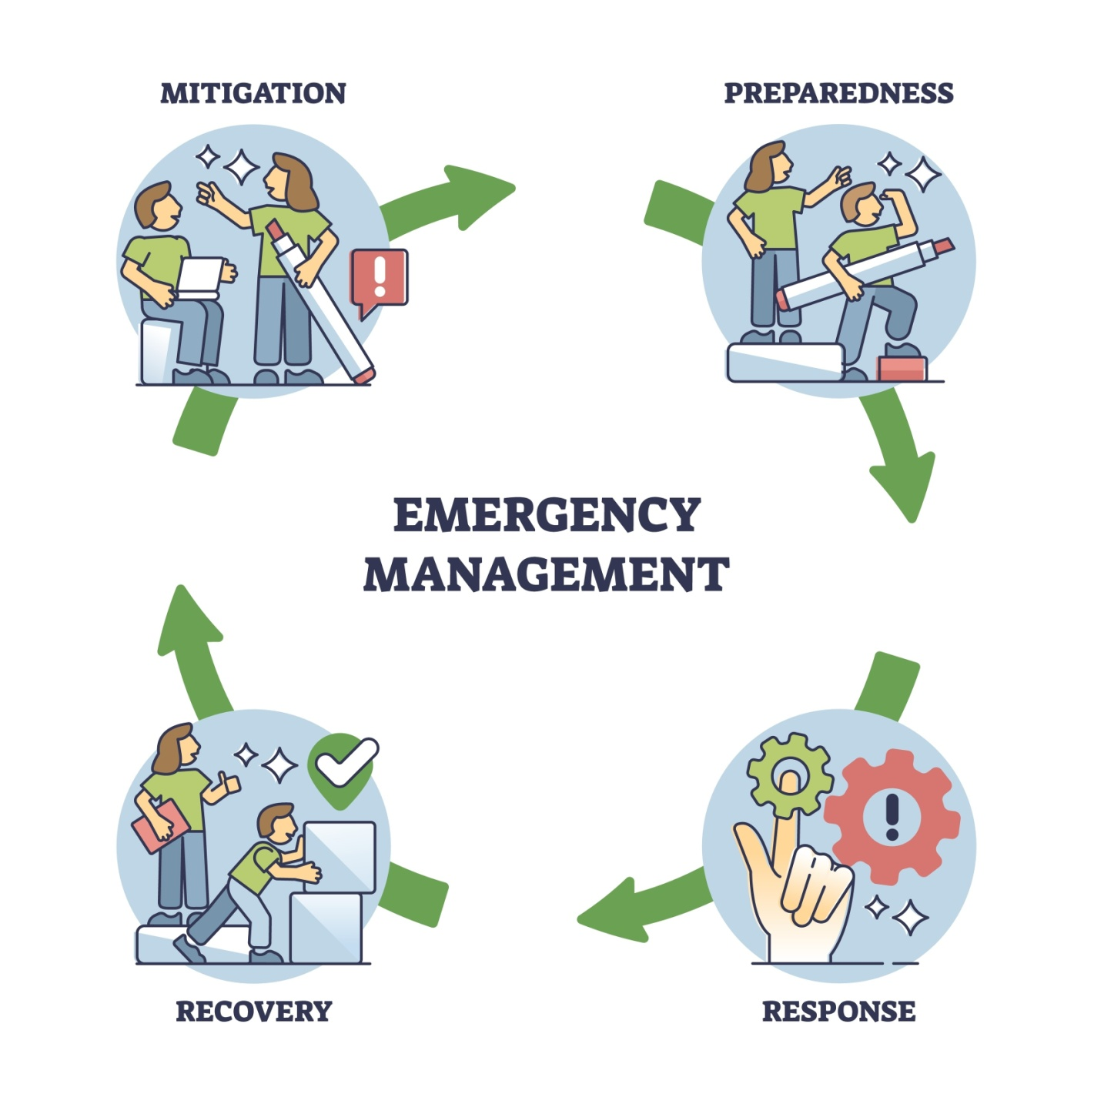
Shutterstock

Phase 1: Verification (Flutter UI)
- User selects "Existing Client" on the setup screen.
- User inputs their Outlet Code (e.g., REST001).
- Flutter calls the Node.js /api/recovery/verify endpoint.
- Node.js queries the Google Apps Script. If valid, it returns the property name and enables the "Recover System" button.

Phase 2: Execution (Node.js Backend)
When the user confirms the recovery, the Node.js backend takes over and executes the following sequence synchronously:
- Rebuild Identity: client.json is recreated using the verified cloud data.
- Restore Configs: config.enc and config.json are downloaded to restore database credentials.
- Fetch Database: The latest .enc file is downloaded into memory.
- Decrypt & Extract: The script reads the first 16 bytes (the IV), decrypts the remaining payload using the AES secret, and extracts the .sql file.
- Inject Database: psql is spawned to rebuild the PostgreSQL tables.
- Confirmation & Restart: Node.js sends a 200 OK success response to Flutter. Flutter displays the "Recovery Complete" dialog. Node.js executes process.exit(0) 3 seconds later to force a clean system restart.

6. Troubleshooting Guide
Symptom | Probable Cause | Resolution
Flutter dialog shows early, but data isn't restored. | Node.js sent the HTTP response before the await tasks finished. | Ensure res.json({success: true}) is at the absolute bottom of the try block in recoveryController.js.
App crashes infinitely upon creating client.json. | Nodemon/PM2 is watching data files and restarting on write. | Run the server with --ignore client.json or ensure the executable is running as Administrator.
Backup uploads successfully but size is 0 MB. | Local pg_dump failed (bad password or empty DB). | Check the local backup.sql before encryption. Verify config.enc holds the correct PostgreSQL password.
Google Drive folder is cluttered with config.enc files. | Missing overwrite logic in the Cloud Script. | Ensure the Apps Script upload_config action calls setTrashed(true) on existing config files before creating the new one.

